


Helwan University
Faculty of Computers and Artificial Intelligence
Software Engineering Program
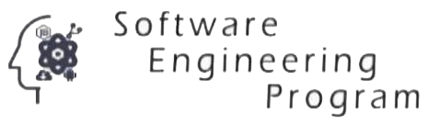

LegalMateAI
A graduation project dissertation by:
Ebrahim Ebid Sadek Ebid (20225102)
Demian Magdy Fayez Twadros (20225146)
Mariam Azmy Elshayeb Abdelnor (20225231)
Karim Khaled refay (20225201)
Yahia Mohamed Saad Eldin (20225255)

Submitted in partial fulfilment of the requirements for the degree of Bachelor of Science in Computers & Artificial Intelligence, at the Software Engineering Program, the Faculty of Computers & Artificial Intelligence, Helwan University
Supervised by:
Dr. Mohamed Marie
June 2026

